Bonus Assignment Questions

1. How many rows does your final query have? [1] **125**
2. 2. Knowing that power query is case sensitive, which of the following steps should you take prior to filtering your subtotals to ensure your query will work when the underlying data is updated? [1] **Format Column to UPPER case**
3. What were the DELIVERY sales for REGION C for BEEF BURGERS (rounded to the nearest $)? Do not include symbols or decimals in your answer. [1] **$7,139**
4. Attach ONE pivot table that illustrates the answer to question 3 and uses conditional formatting to highlight your answer (e.g. the bottom value.) [2]

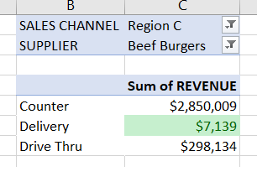

1. Which CATEGORY contains the BURGER item with the lowest percentage of Total Sales in the DRIVE THRU CHANNEL? [1] **Other Burgers**
2. What % of total sales (rounded to 0 decimals) does the highest selling burger have? **70%**
3. Attach ONE pivot table that illustrates the answer to question 5, and uses conditional formatting to highlight your answer (e.g. the bottom value.) Round your values to 1 decimal number. [2]

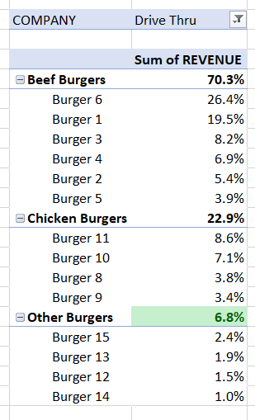

1. Build a pivot table to show the percentage distribution of total sales for all BURGER items by CATEGORY & SALES CHANNEL. Please show subtotals. What % of total sales (rounded to 0 decimals) does the highest selling burger have? [1] **38%**

What combination of REGION and SALES CHANNEL has the highest sales of BURGER 6? Region C and Counter

1. Attach ONE pivot table that illustrates the answer to question 7, hiding field headers and renaming value to Sales by Burger. [2]

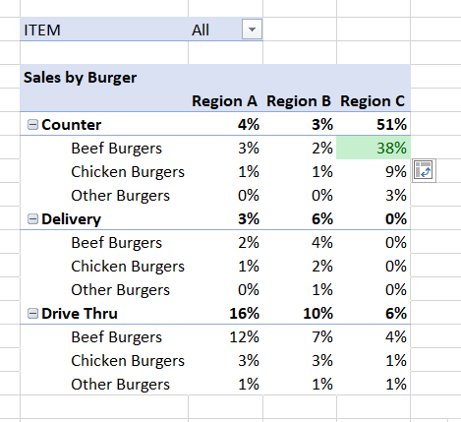

1. What combination of REGION and SALES CHANNEL has the highest sales of BURGER 6? [2]

**Region C**

**Counter**

1. Upload an image file of a chart that illustrates your answer to question 9, showing CHANNEL

